Project Report

Product Name | Advanced Certificate in Web Development
Qualification Name (NICF) | ITSF - Advanced Certificate in Information Technology (Application Development)
Product Name | Front End Web Development
Module Name (NICF) | ITSF - Front End Web Development

Student name |  | Assessor name
VIDDY VIRSTANDI PARAMANAYAKA ANDANAWARI PURNAMA |  | Anandita Bose and Rahul Raghubansi
Date issued | Completion date |  | Submitted on
06 May 2022 | 10 June 2022 |  | 10 June 2022
Project title | Development of website for a Training Organization

Learner declaration
I certify that the work submitted for this assignment is my own and research sources are fully acknowledged.

Student signature: Date:

Content
- Project background
- Project Objectives
- Requirement Specifications
- Task 1
- Task 2
- Task 3
- Task 4
- Task 5
- Task 6
- Task 7

Project Background
Lately, many want to become web developers, but some of them don't understand how to use HTML, CSS, Java, or even Microsoft Office.

ABC Learning Center answers all of that. At the ABC Learning Center they can learn about HTML, CSS, Java, and Microsoft Office. With a simple and easy interface they can register quickly and easily.
Project Objective

- Project Objective
To make it easier for users to register for learning HTML, .Net, Java, and Microsoft Office
- Proposed Solution
By making a simple and simple web so that users can easily register

Tools & platform used
In the Final Submission I use Visual Studio Code to make HTML, CSS, and Js. Apache Tomcat 9.0 to open my HTML page. And I use Google Chrome to open the Apache Tomcat 9.0
Requirement Specification
i need to design and develop the website using HTML, JavaScript, CSS, jQuery & Ajax. And I required to design following pages in this website :
1. Common Content
a. Header
b. Footer
c. Navigation
2. Home Page
3. About Us Page / Profile Page
4. Course Listing Page
5. Course Details Page
6. Course Schedule Page
7. Contact Us Page
8. Lead Registration Page
9. Registration Thank You Page
10. Privacy Policy Page
Task 1
Task Statement:
1. List and document features in a requirements specification document
a. Include sections for Website, Lead Generation form and its Administration.
2. Include it as part of Project Report.
Solution:
Home Page
About Us Page
Course Listing Page
Course Details Page
Course Schedule Page
Contact Us Page
Lead Registration Page
Registration Thank You Page
Privacy Policy Page
Registration for Admin
Task 2

Task Statement:
1. Create an Information Architecture & Storyboard for the website
2. Propose the Information flow for a Leads generation form & Its Administration (Login
Not Required)
a. User must be able to Add, Edit, Delete & List leads
3. Include it as part of Project Presentation

Solution:
Included in Project Presentation
Task 3

Task Statement:
1. Develop the HTML Pages required for the website
2. Develop the Lead Generation Form & Administration System pages for Lead Generation
form management.
3. Include the screen capture as part of Project Presentation

Solution:
Included in Project Presentation

- Task 4

Task Statement
1. Propose & use jQuery Components such as menu, popup etc as part of the website.
2. Design the required HTML for jQuery Components.
3. Provide screen capture as part of Project Presentation.

Solution
Included in Project Presentation

- Task 5

Task Statement
1. Write a paragraph on the effectiveness of the designed Lead Generation Administration
System.
2. Write briefly on effectiveness of the User interface according to 2 metrics
3. Include it as part of Project Report.

Solution
Lead Generation is an effective method to promote or advertise products or business. The Lead Generation is used to attract potential customers, and guide or show them your products or business in unique and interesting way (Hubspot, 2022). In this case, ABC Learning Center target costumers are those who are interested in the field of Information Technology. ABC Learning Center will use website to promote and showcase their products/offers to attract potential customers, for example: showing the benefits if they apply for the courses, showing what they will learn, showing the company origins, privacy policy, and each course schedule and subjects.
The website landing page is the most crucial part to make the potential customer (visitor) stay to browse the products or offers. The ABC Learning Center with its brand-new website will have “call-to-action” features or display image that will attract interest and curiosity of the visitor. If the visitor stays and browse through the website, they can fill out the “registration form” that is marked with “red color text” on the right side of the navigation bar. The navigation bar has a “sticky element” so when the visitor is scrolling throughout the website, they can still see the register button which is marked differently than the rest of navigation menu.
When the visitor submitted the registration form, the ABC Learning Center staffs are able to immediately view the submitted data and will contact the customer for further coordination or arrangement.

Metrics for Lead Generation Form
• No more than 2 minute required to fill the Registration Form.
• The registration form has validation feature to avoid unwanted data or error.
• The register button is included on the navigation bar for easy access.
- Task 6

Task Statement:
1. Make changes to User Interface based on effectiveness metrics identified in Task 5.
2. Make the changes to HTML, CSS & Javascript.
3. Include the screen capture along with list of modifications made as part of Project
Presentation.

Solution
Included in Project Presentation

- Task 7

Task Statement
1. Create a User Guide for Lead Generation form and its Associated Administration
Module.
2. Include it as part of Project Report

Solution

- Hover your pointer to course section, and choose the course
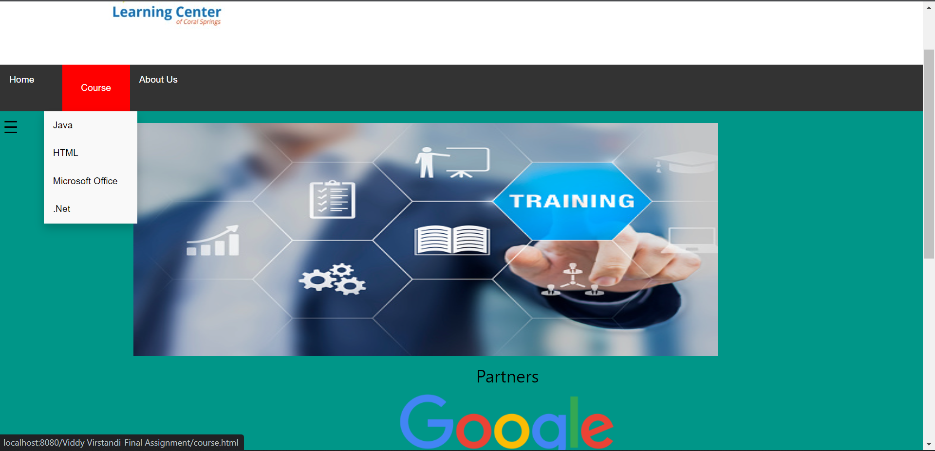

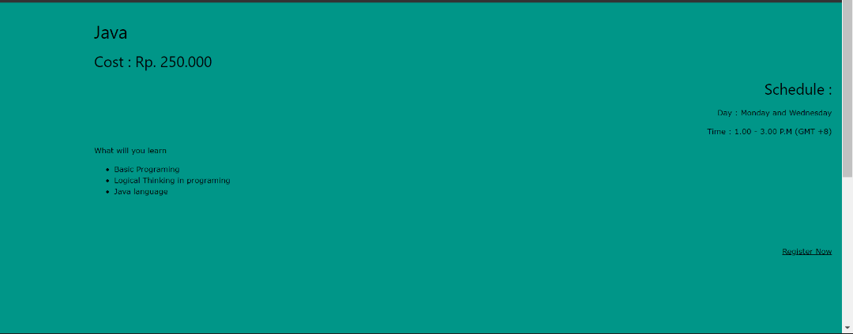
- For example you choose Java course, then click on “Register Now”

- Fill in the registration Form, and click the Submit button
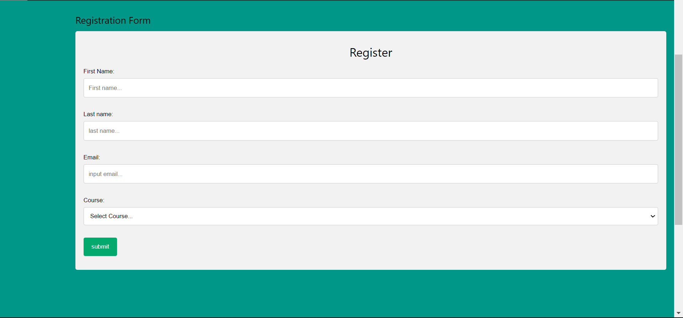

- For “Admin” you can change /register.html to /admin.html
